**Setting up the cloud environment in your local system**

1. First Download the Pycharm Community latest version by going the below link(the link may change now better google search and download)

<https://www.jetbrains.com/pycharm/download/#section=windows>

below is the screenshot for your reference.

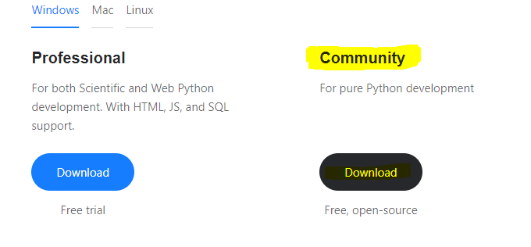

1. After that download required packages for google cloud platform, open pycharm and click on file->settings->project interpretor, After click on the on right side there is symbol(+) click on the that it opens new page search for **google-cloud package**  and click on install and then click ok, below is the screenshots for your reference

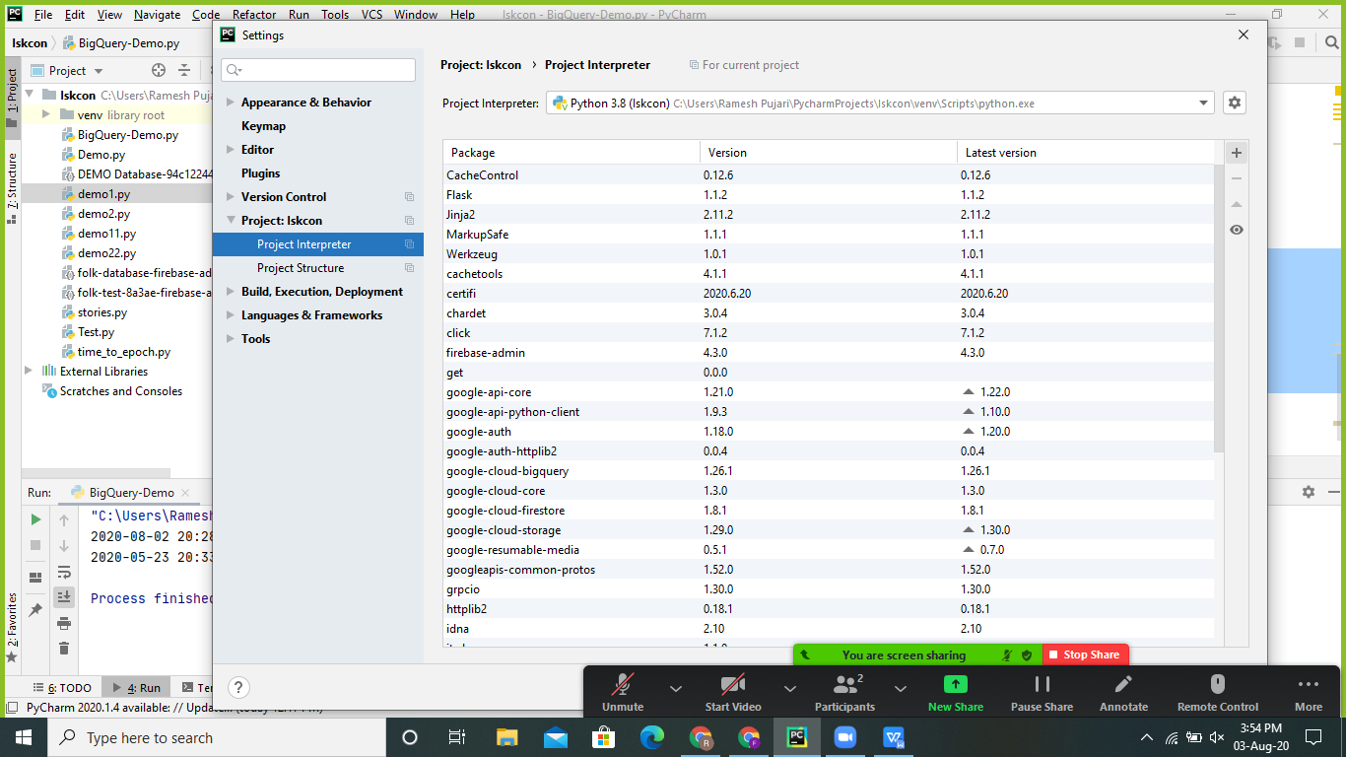

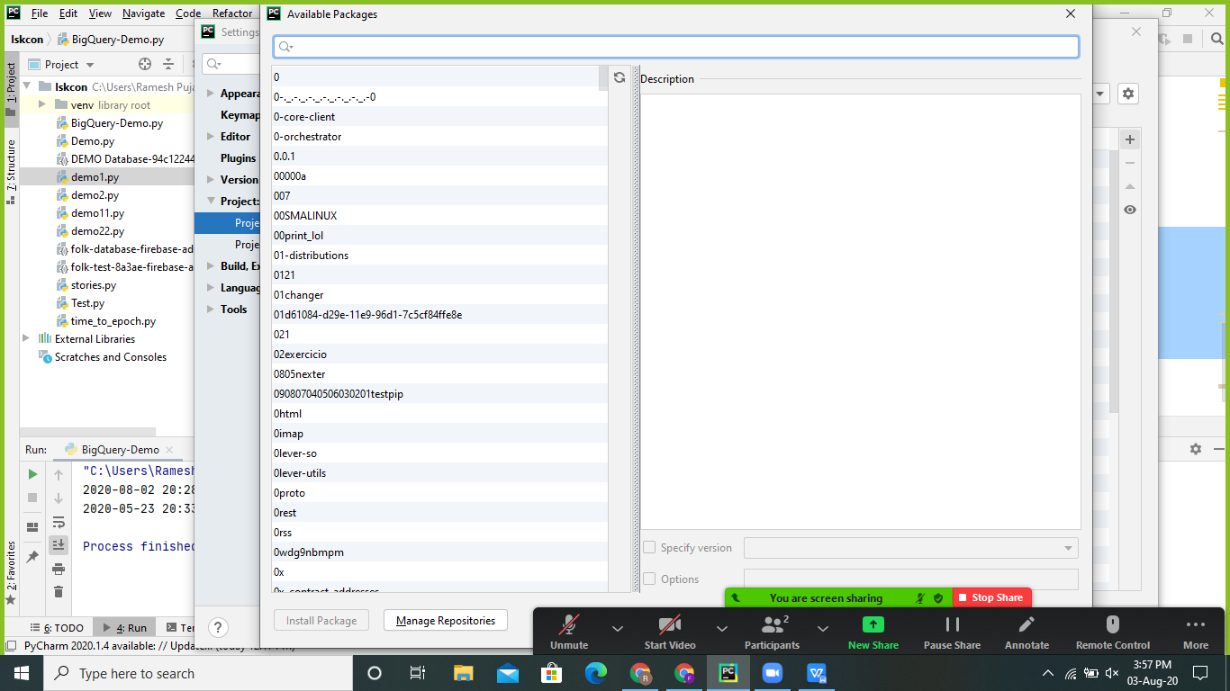

Note: if you want any packages in future , follow the same process the required package will install

Now setting up google cloud platform locally completed